Name : S.PRATEEKSHA Course : Software Engineering
Reg No : 192572137
Experiment – 3

Question : The stakeholders have conflicting views on the user interface design for an E-Commerce mobile app. Create a prototype using Figma tool to discuss with the stakeholders to get their feedback and approval.
Step 1: Open Figma

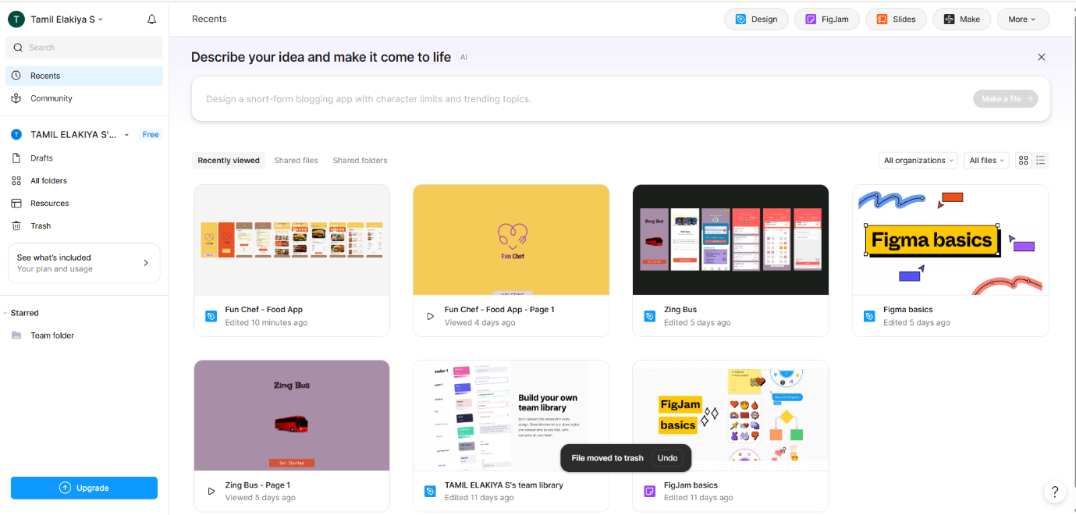

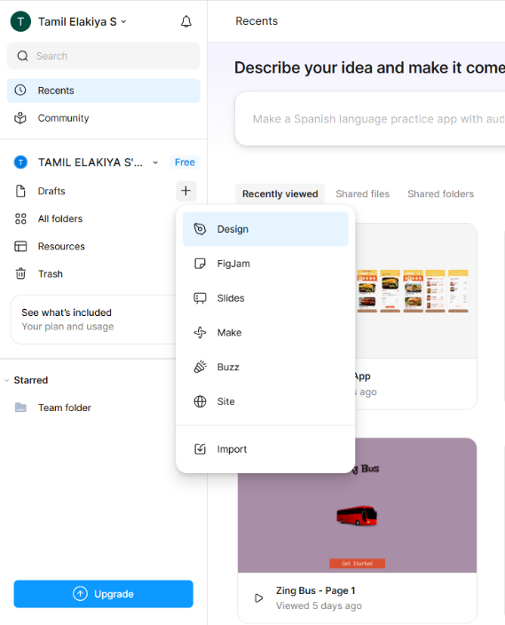
Step 2: Create the Project

Step 3: Design the Login / Sign-Up Screen
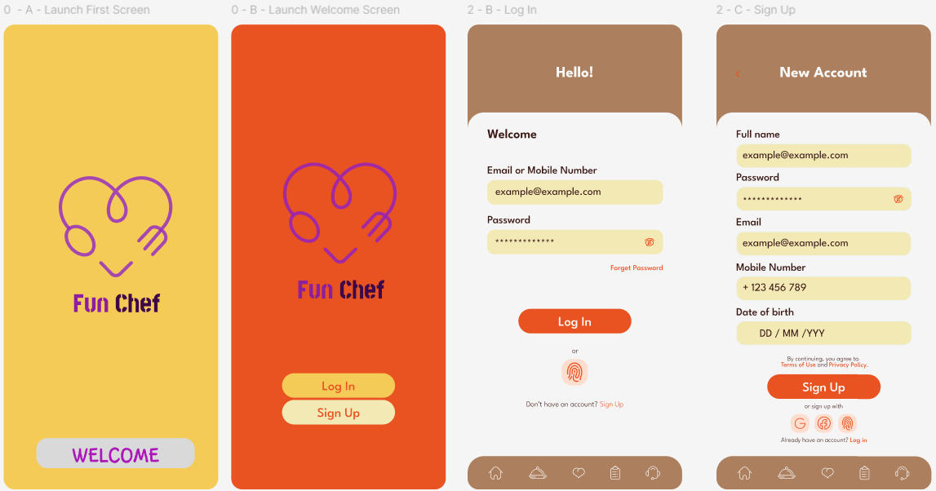

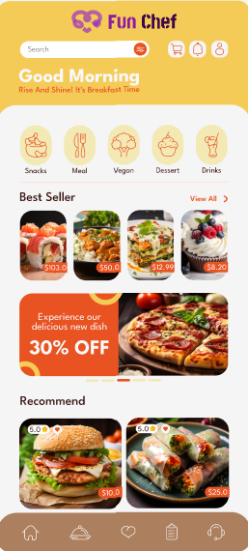
Step 4: Design the Home Page

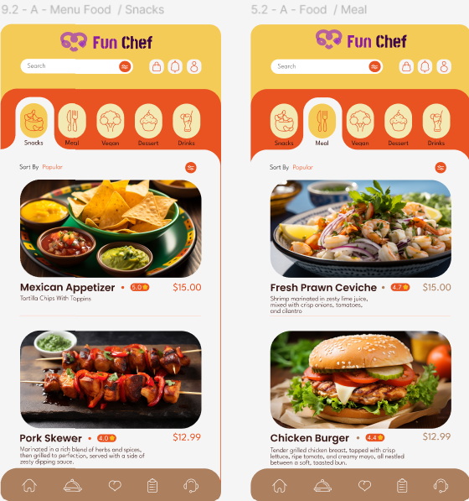
Step 5: Design the Product Listing Page

Step 6: Design the Product Details Page
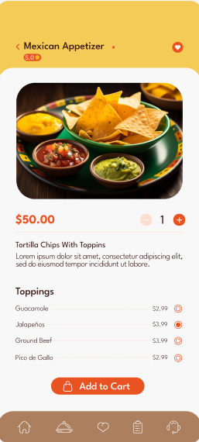

Step 7: Design the Shopping Cart Page
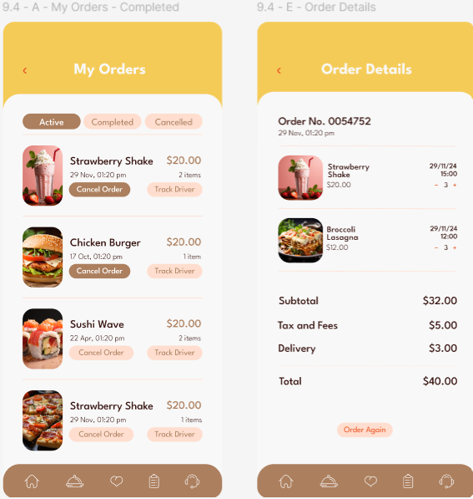


Step 8: Design the Order Confirmation Page

Step 9: Connect the Screens
